Kinematics Analysis All Subjects

Began to assess the kinematic quantities found from Noraxon related to minimum, maximum, and range degrees of motion for each given joint. I utilized averages for most of the analysis here to understand the general trends across all subjects, but I can do individual analyses on any case study as well.

# Averaging Ranges:

* 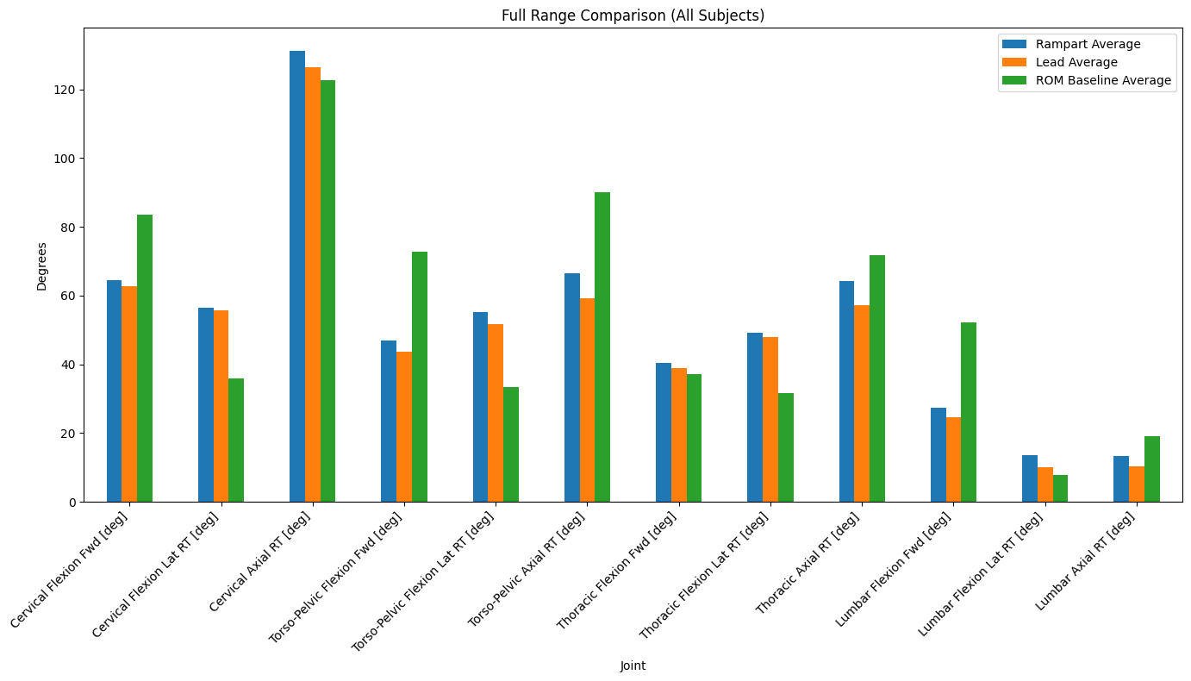
* It appears that there might be some bad data relating to the cervical ranges. We noticed some high degrees of cervical axial left and right. We are a little concerned about that.
* Since the values are reflected right to the left, I used the positive right-hand rule to get the values for the range since they would be the same.
* If you would like to see the right and the left, I can do that as well.
* 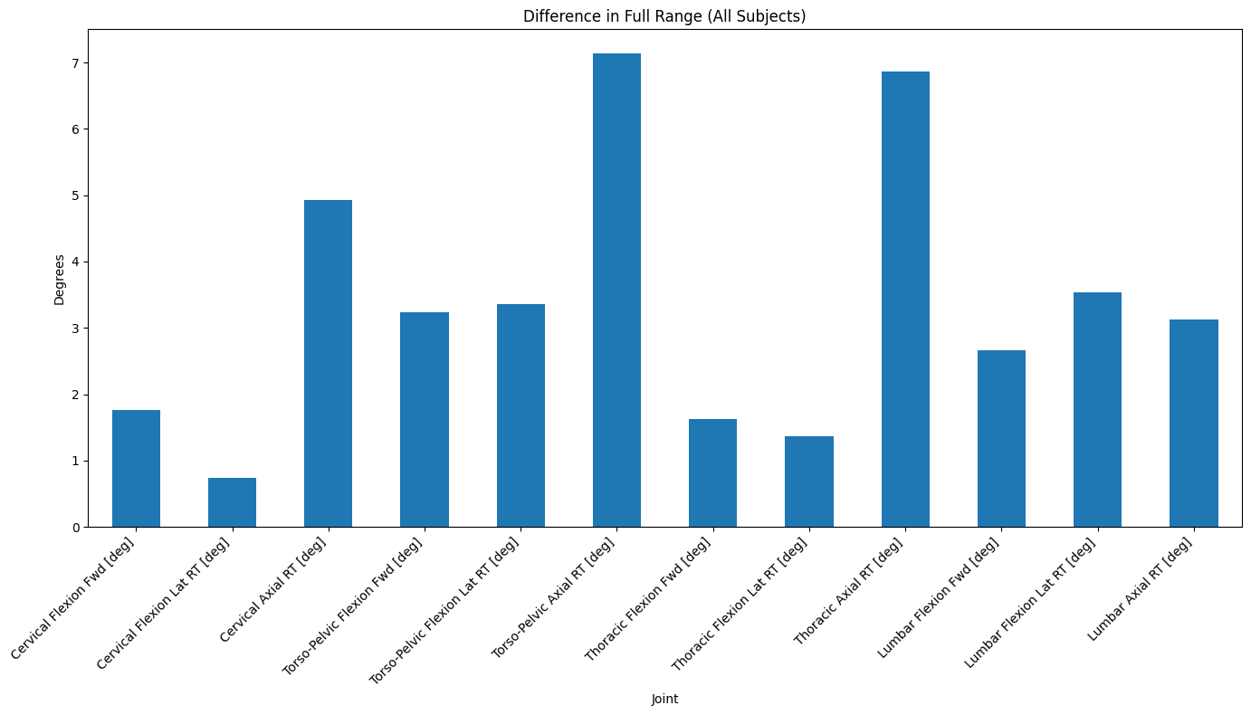
  + Found by subtracting the lead averages from the rampart.
  + Generally, the differences between rampart and lead showcase that rampart allows for more range of motion. This appears to be a good thing. That is as long as they aren’t moving too much more now outside of the optimal degrees of motion that we will assess the thresholds for.

# Averages of Minimum Degrees

* 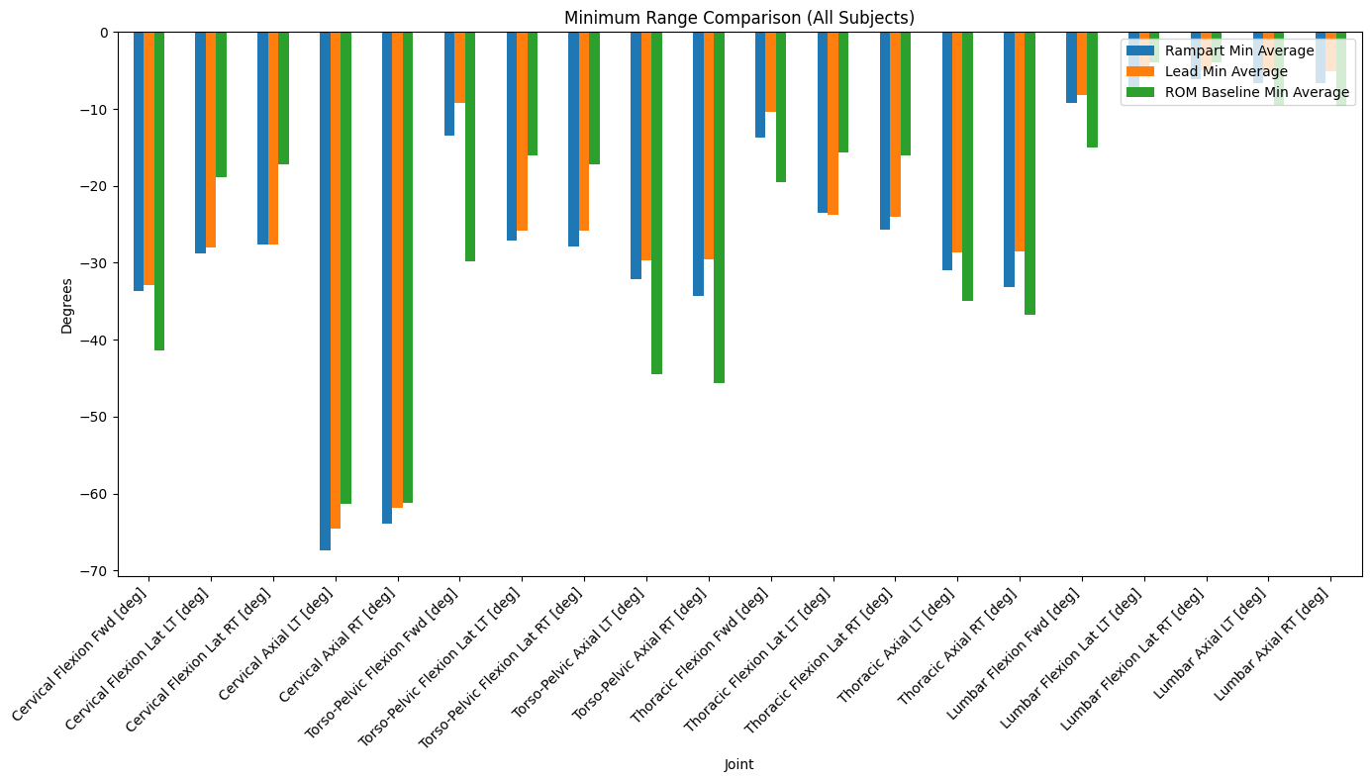
* 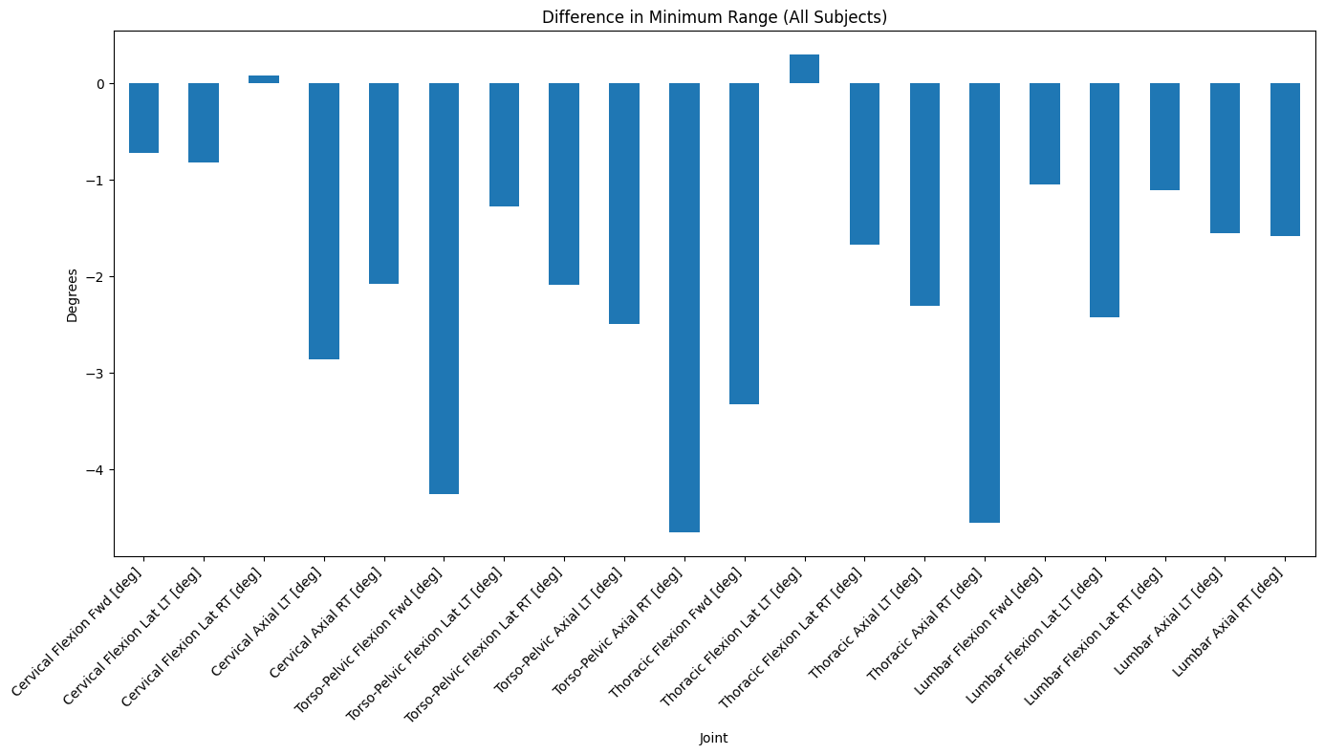
  + Found by subtracting the lead averages from the rampart.
  + Generally, the rampart device allows for more minimum range degree of motion compared to the lead vest.

# Averages of Maximum Degrees

* 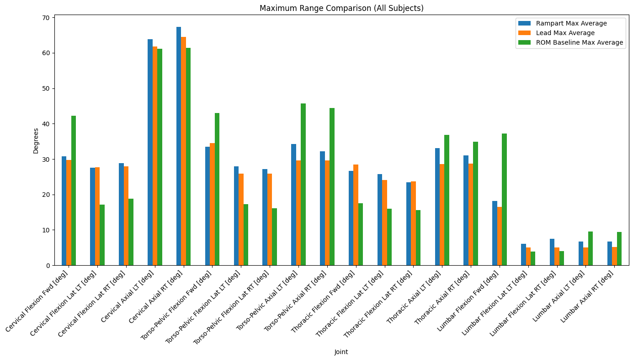
* 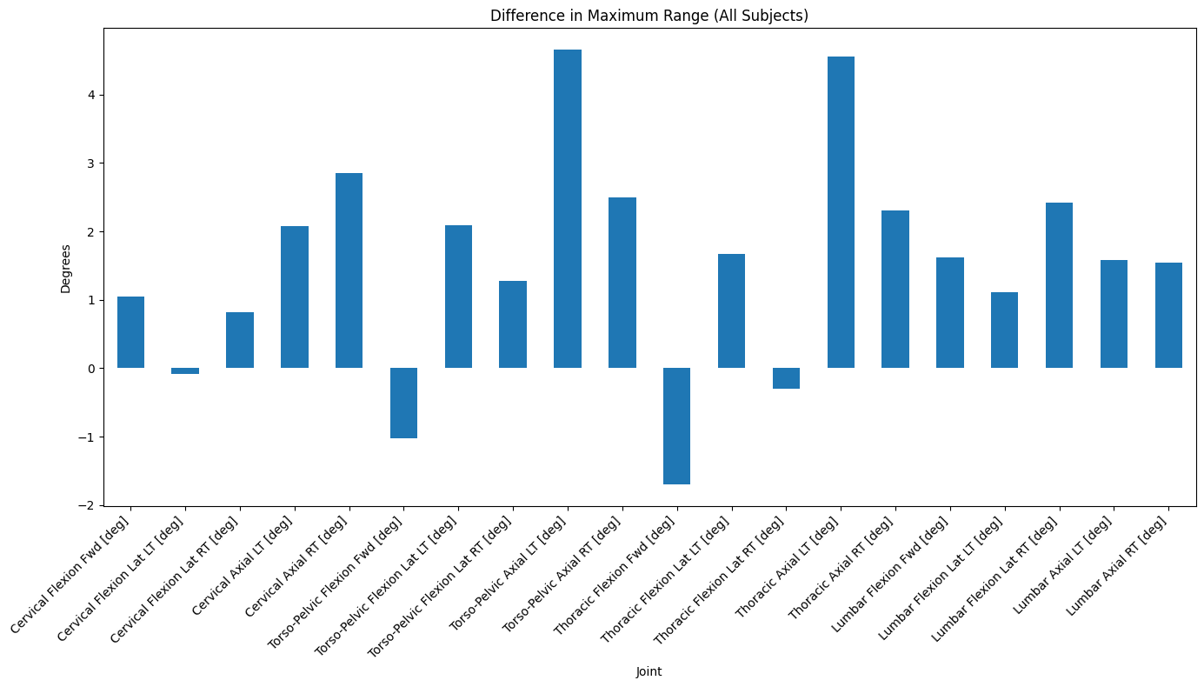
  + Found this by subtracting the lead averages from the rampart.
  + Once again, we see that the rampart values appear to showcase more potential for range of motion, but we need to be careful they aren’t exceeding optimal ranges of motion, which we assessed in the degree thresholds below.

# Assessing 20 Degrees Thresholds

* 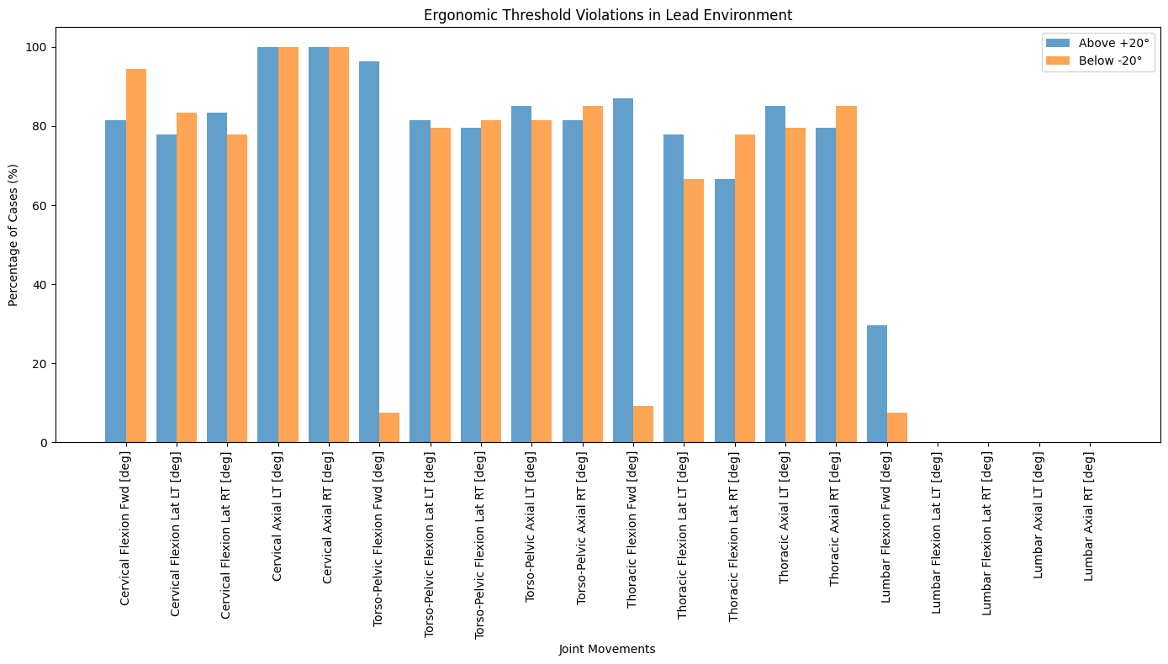
* 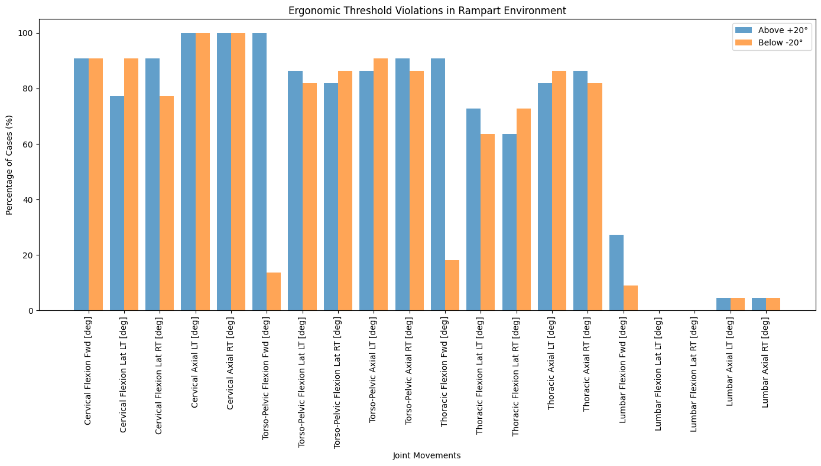
* It appears that the rampart slightly allows for more degrees of motion; however, it appears that the individuals are then going outside of the optimal range of motions associated with minimal risk based on the study provided.

# Assessing 60 Degrees Thresholds

* 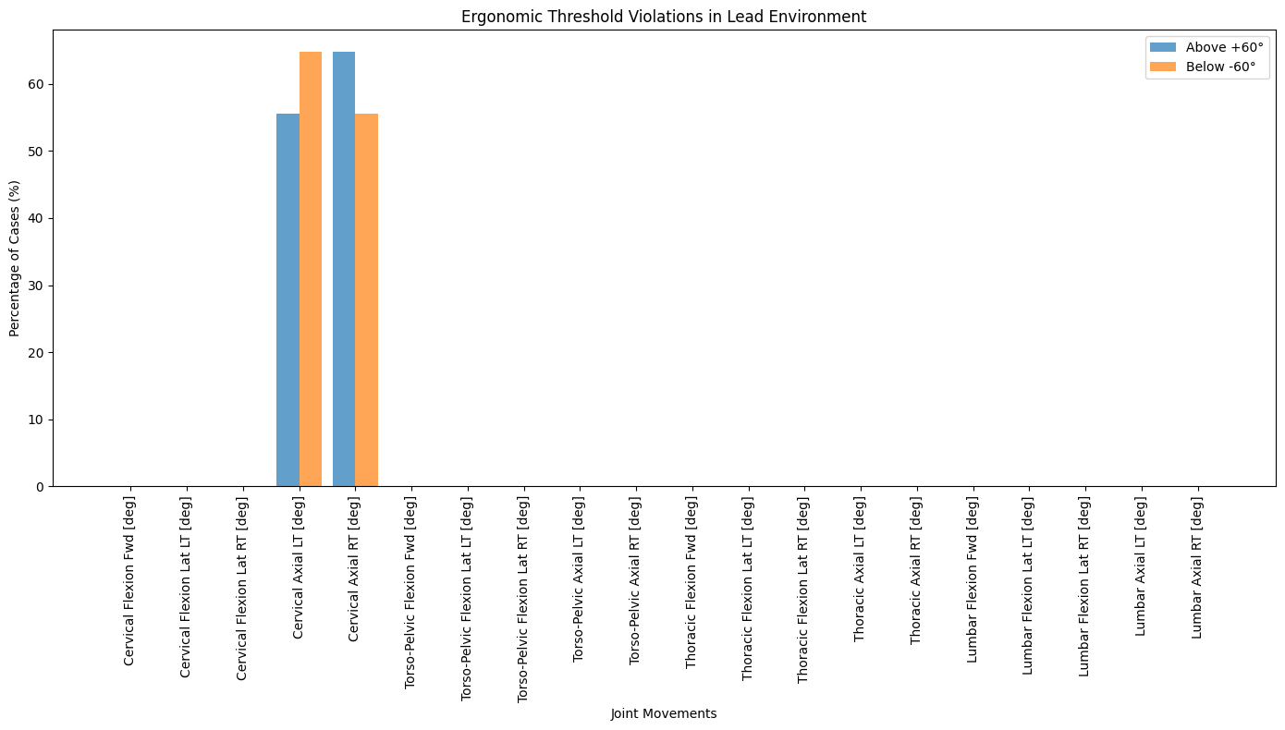
* 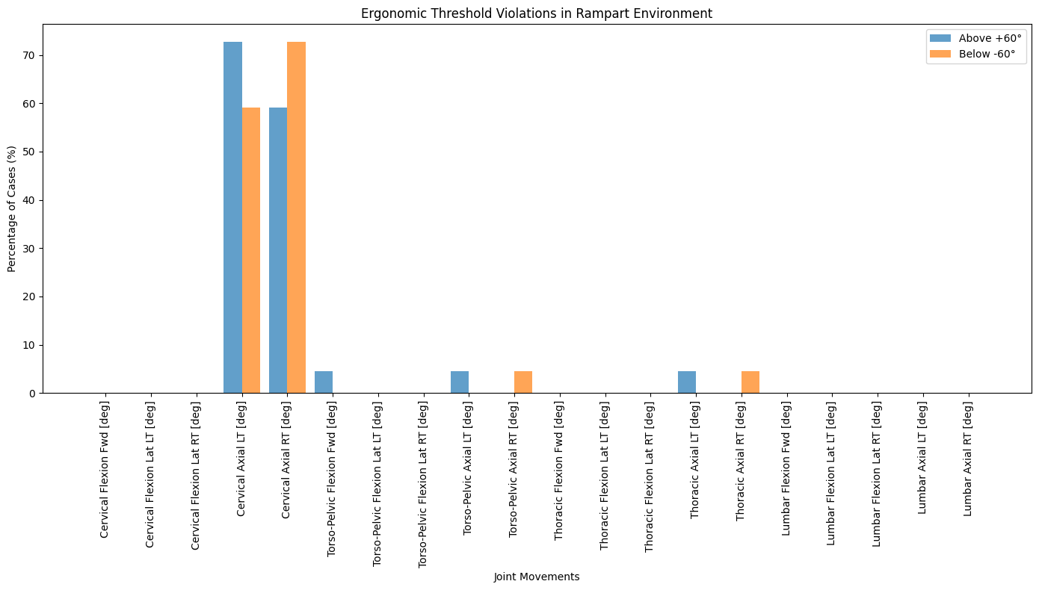
* It appears that overall the degrees of motion are more constricted for the lead vest compared to the rampart device. There are times where the rampart cases showcase more elevated risk, but it is important to also consider the isometric considerations that the lead vest seems to be very constricting and thus will keep joints in a certain state for a long period of time.
* Overall, the individuals that are above 60 degrees of motion are definitely at high risk though for potential joint related injuries.
* Ergonomically, there is a lot that can be assessed and variables such as height and other factors may play a role in the results that were found. It is very dependent on the joint function of the individual ultimately.

# Baseline Data Differences

* Based on the data, subject 6 showcased the largest max and minimum amounts of degrees in the respective joints. The data for this subject is below:
  + 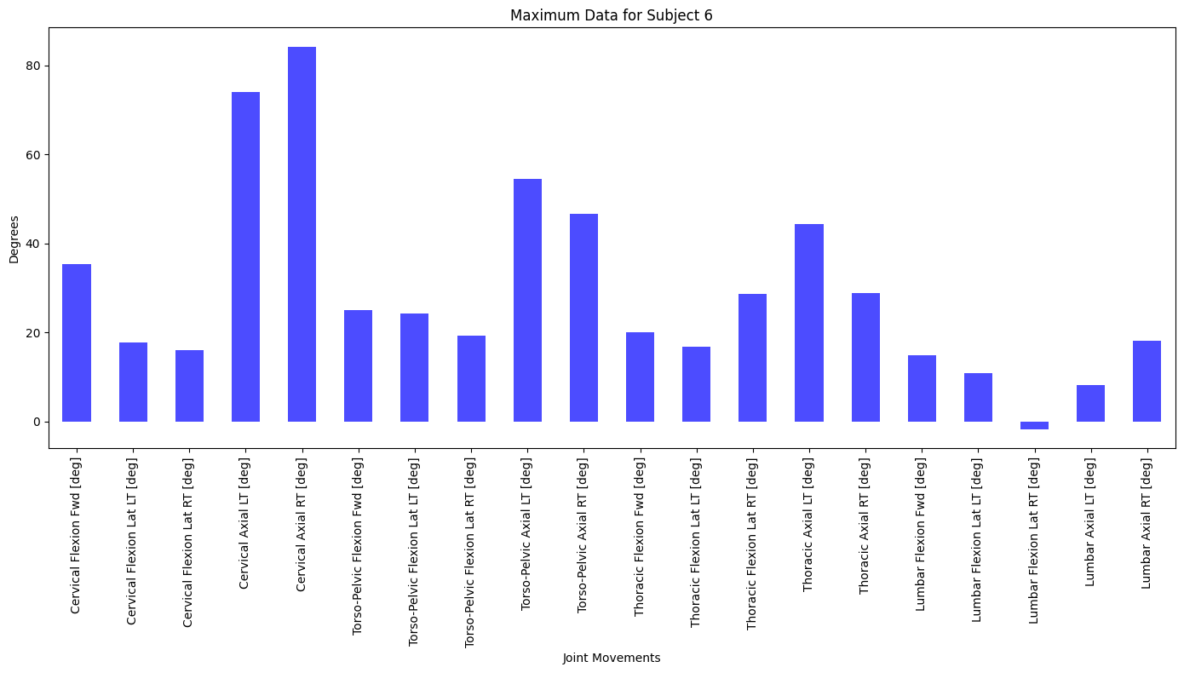
  + 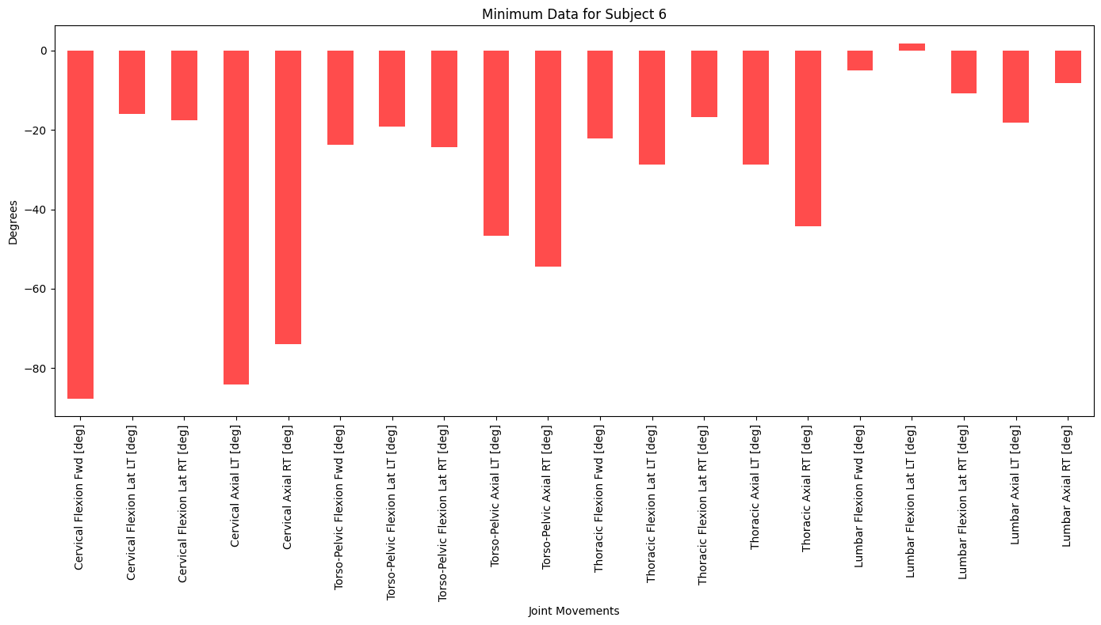
* Now I will showcase the subjects that showcased the largest amounts of ranges in degrees for the given joints.
  + 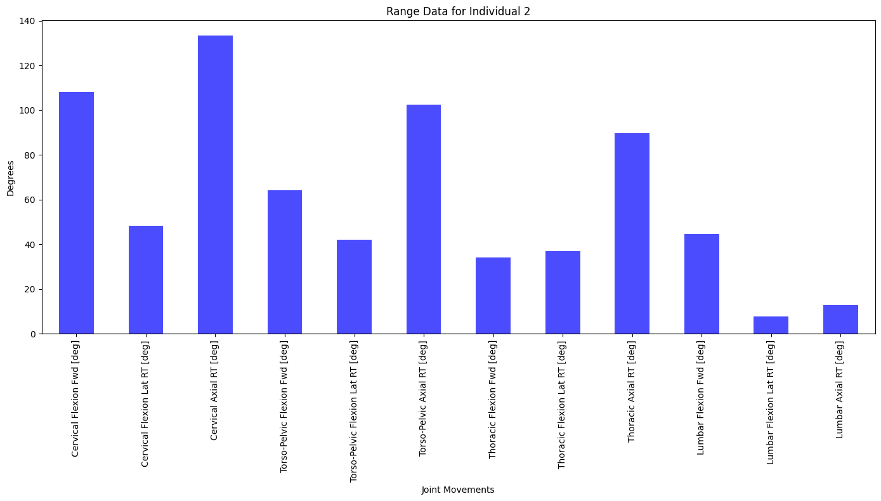
  + 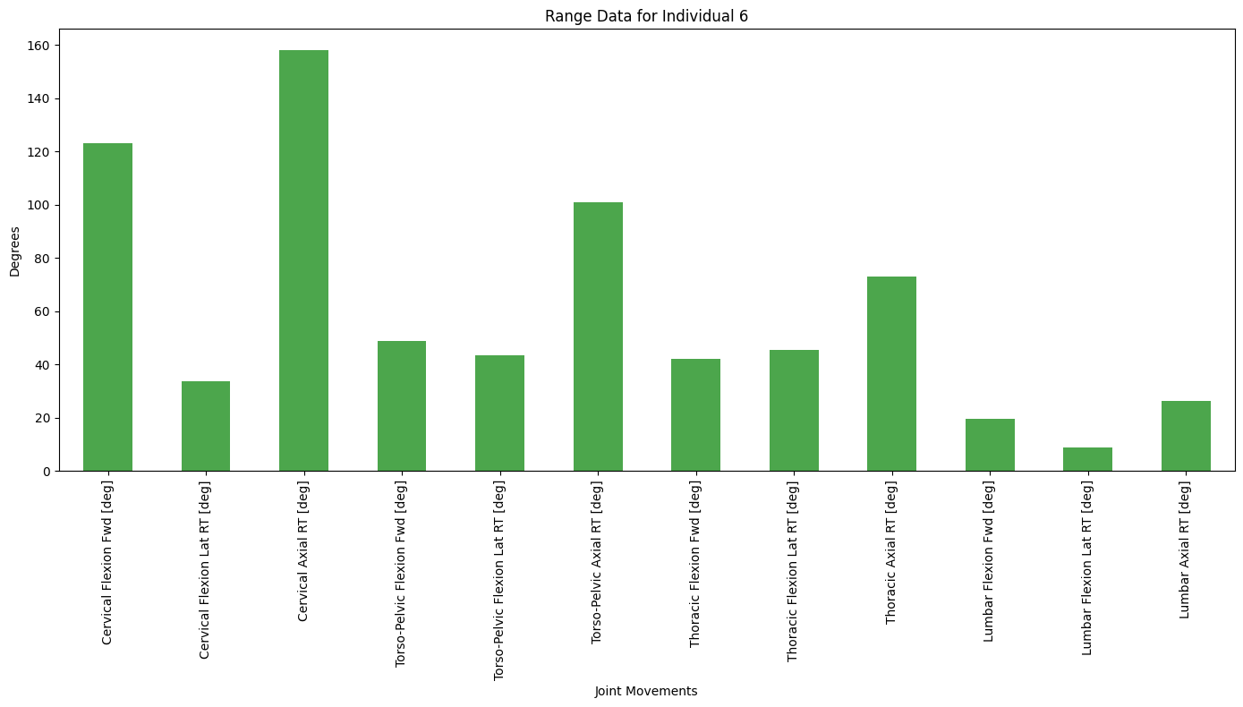
  + 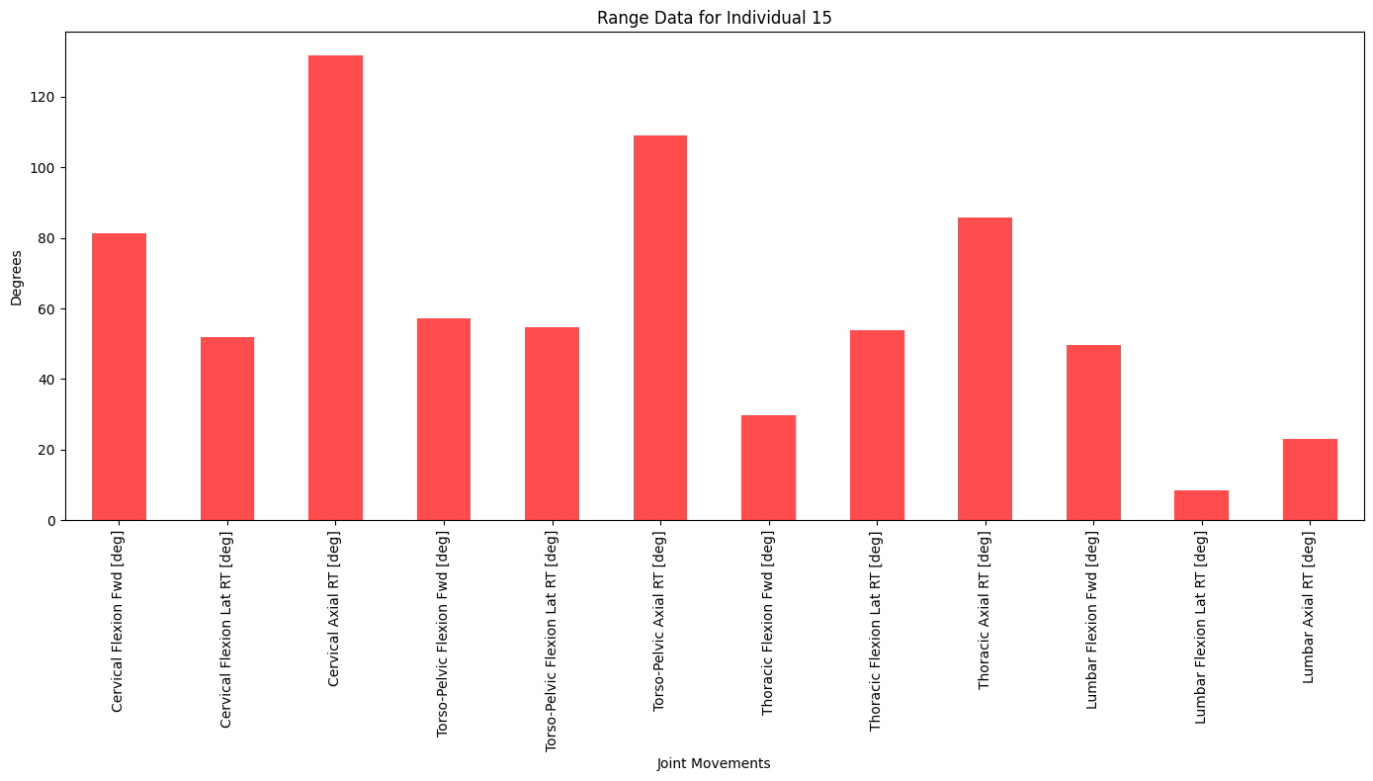
* Here is the subject with the smallest amount of degrees in range:
  + 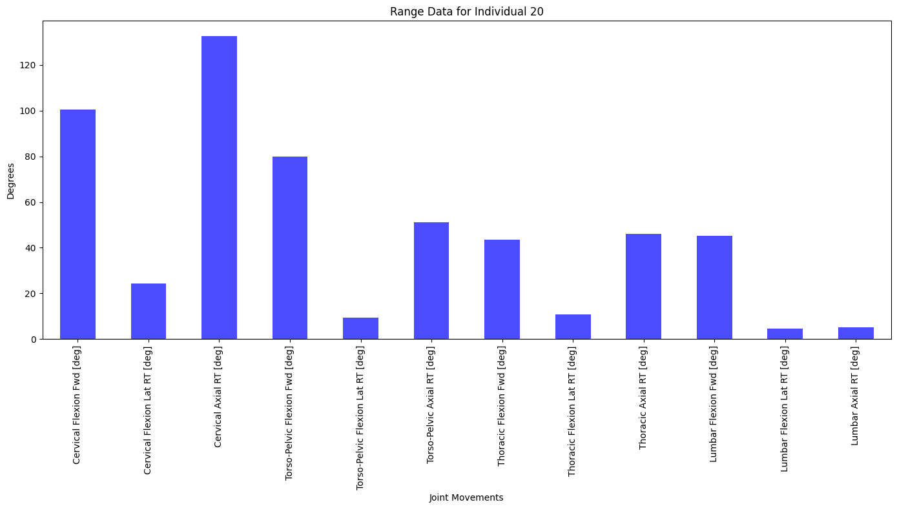
* Now showcase the differences in ranges of subject 6 - subject 20
  + 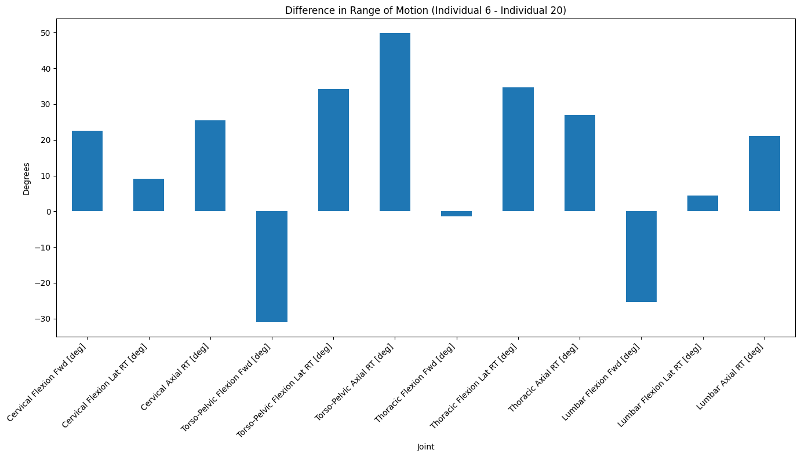
  + This showcases there is potentially a vast range of difference in most of the joints for each subject to work with according to their baseline. There might be more to explore how these particular subjects on the extremes of things react to one another in the lead vest vs. rampart device.
* Let me know of any other questions that you might have or want answered and the data can also be found merged for CSVs.
* Further analysis will look at percent of time in thresholds of risk.